Exploring Data

- Check counts (rows, distinct symbols, distinct sectors)
SELECT
COUNT(*) AS total_rows,
COUNT(DISTINCT symbol) AS unique_symbols,
COUNT(DISTINCT sector) AS sectors
FROM `projectspractice12.sp500dataAnalysis.sp500data_clean`;

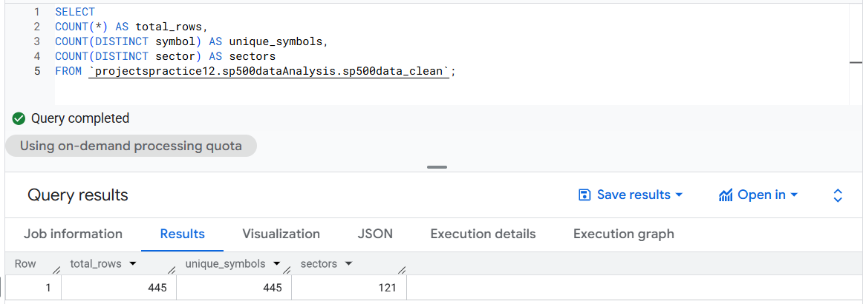
- Distribution Profiling (Sectors)
SELECT
sector,
COUNT(*) AS n,
ROUND(100 * COUNT(*) / SUM(COUNT(*)) OVER(), 2) AS pct
FROM `projectspractice12.sp500dataAnalysis.sp500data_clean`
GROUP BY sector
ORDER BY n DESC;

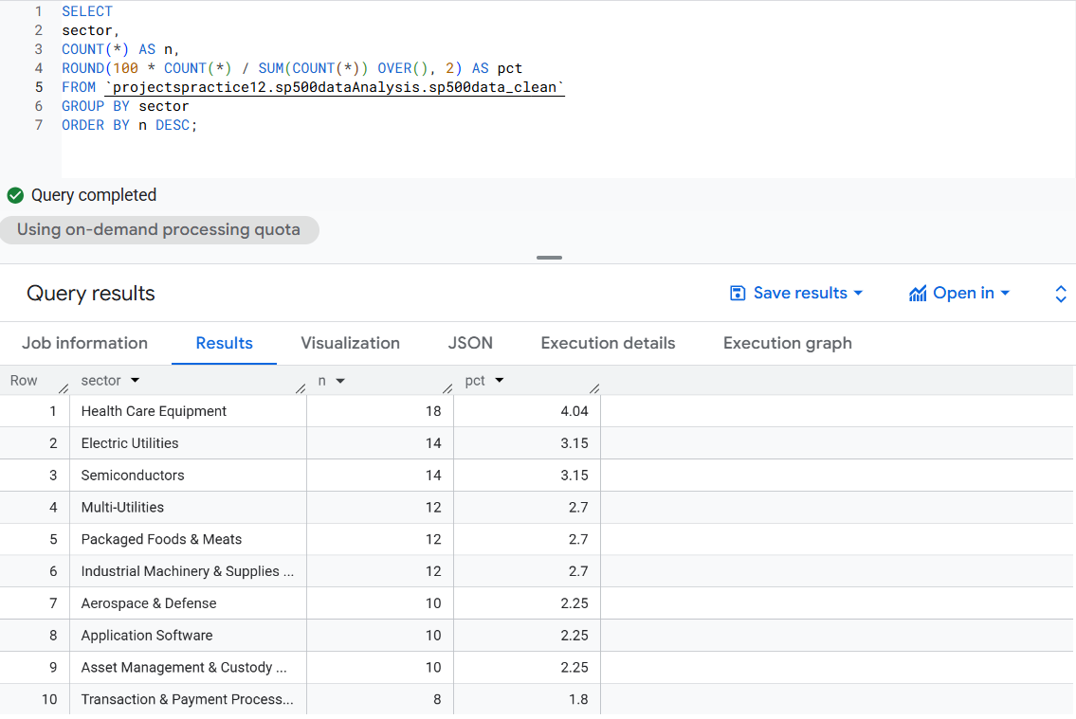
- Summary stats

SELECT
'price' AS metrics,
MIN(price) AS min,
MAX(price) AS max,
AVG(price) AS avg
FROM `projectspractice12.sp500dataAnalysis.sp500data_clean`
UNION ALL
SELECT
'priceToEarnings',
MIN(priceToEarnings),
MAX(priceToEarnings),
AVG(priceToEarnings)
FROM `projectspractice12.sp500dataAnalysis.sp500data_clean`
UNION ALL
SELECT
'dividendYield',
MIN(dividendYield),
MAX(dividendYield),
AVG(dividendYield)
FROM `projectspractice12.sp500dataAnalysis.sp500data_clean`
UNION ALL
SELECT 'ebitda',
MIN(ebitda),
MAX(ebitda),
AVG(ebitda)
FROM `projectspractice12.sp500dataAnalysis.sp500data_clean`
UNION ALL
SELECT
'PriceToSales',
MIN(PriceToSales),
MAX(PriceToSales),
AVG(PriceToSales)
FROM `projectspractice12.sp500dataAnalysis.sp500data_clean`
UNION ALL
SELECT
'priceToBook',
MIN(priceToBook),
MAX(priceToBook),
AVG(priceToBook)
FROM `projectspractice12.sp500dataAnalysis.sp500data_clean`;

